Exercise 5: Feature extraction for tree segments

1. Open and examine the given segmentation (TrainingTrees.shp) in ArcMap

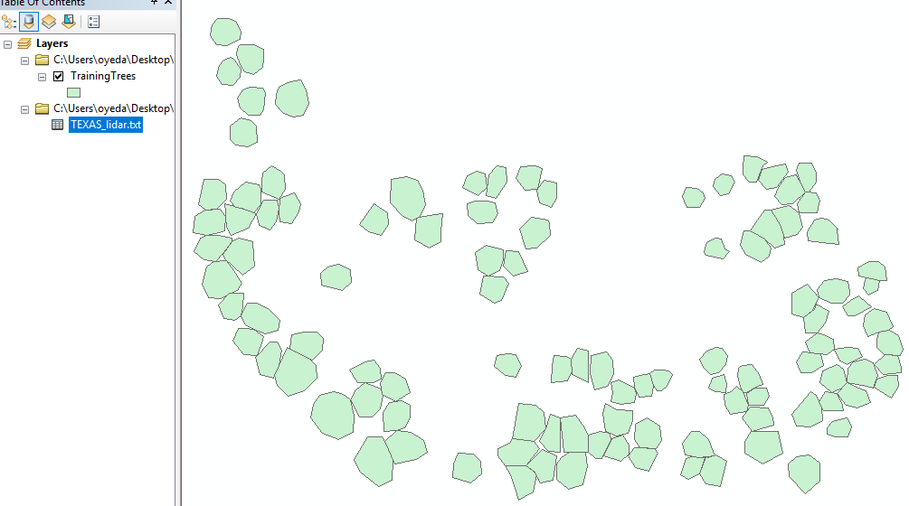

2) Read the Lidar point data to RStudio (script provided)

3) Read the shapefile to RStudio (script provided)

4) Use spatial overlay analysis to detect which Lidar points are located inside the tree

segments (script provided)

subset >2 and <50 because no tree above 50 and should be above 2 to avoid small grases

5) Create a code which calculates the following Lidar features for individual tree

segments. Use only first and single echoes while calculating the features:

• Tree position

o X-coordinate of maximum height observation (X)

o Y-coordinate of maximum height observation (Y)

• Maximum height of the observations (Hmax)

• Mean height of the observations (Hmean)

• Standard deviation of the height observations (Hstd)

• Coefficient of variation (CV)

• Vegetation density, i.e. percentage of observations above 2 meters (VD)

• Quantiles of the height observations (h10-h90)

Hint: When you test the code, use only one tree segment. When the code works well,

create a loop to calculate the features for all the tree segments.

6) Export your features as a csv-file. Draw vertical point height distributions in Excel.

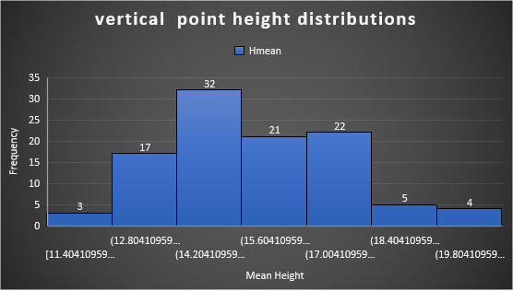

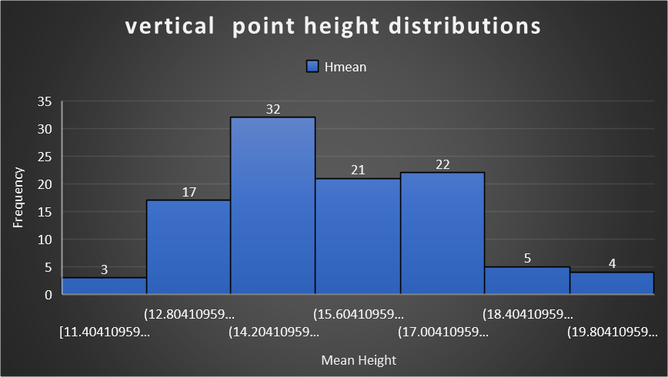

Rounding off to zero decimal place

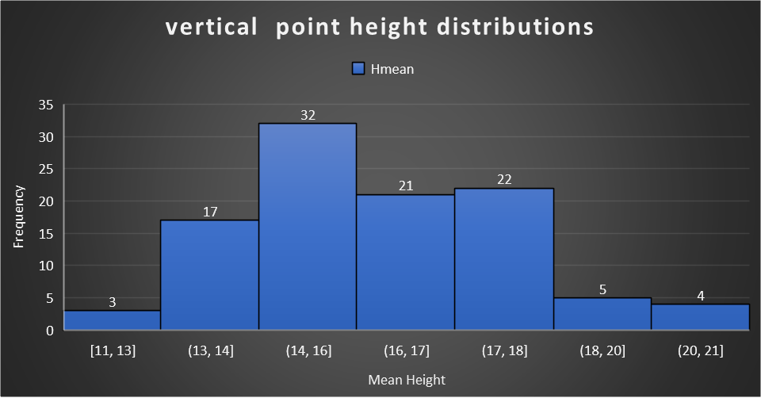

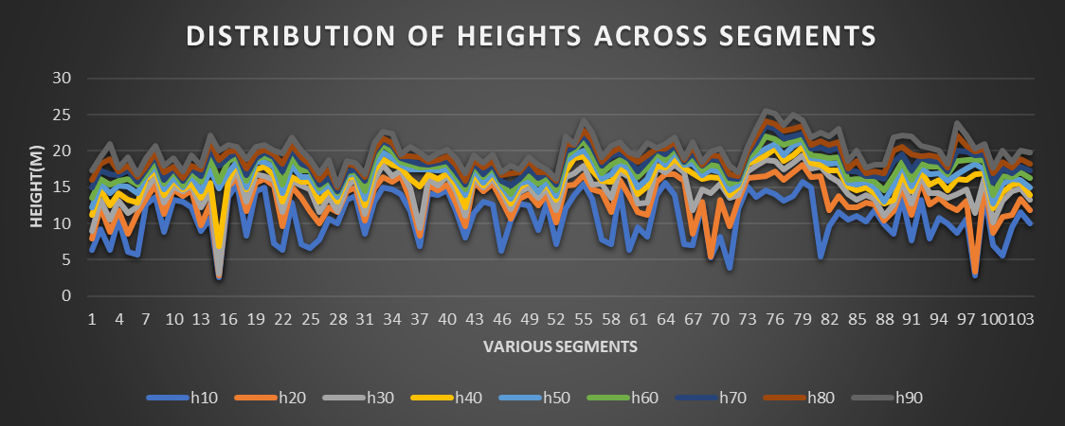

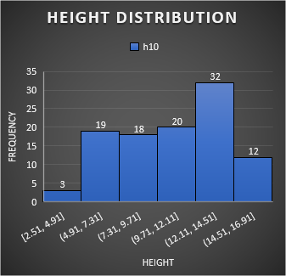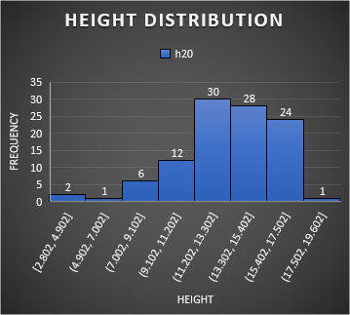

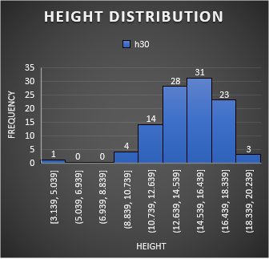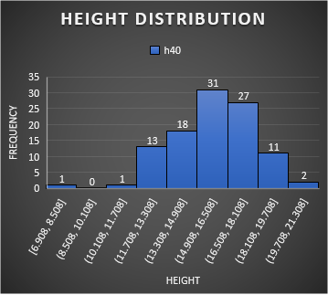

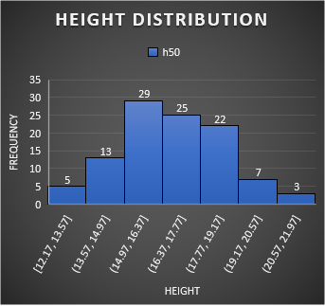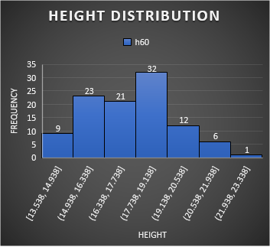

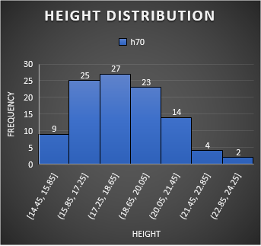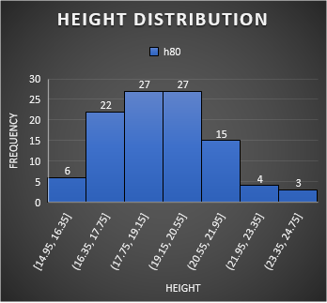

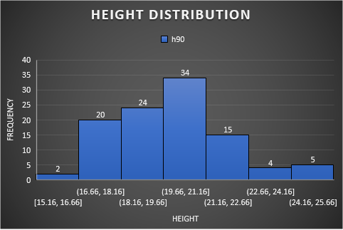

The vertical point height distributions in R

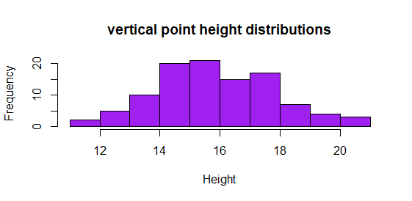

7) Import your trees and calculated features to ArcGIS. Calculate positioning error and

error in tree height for all the trees.

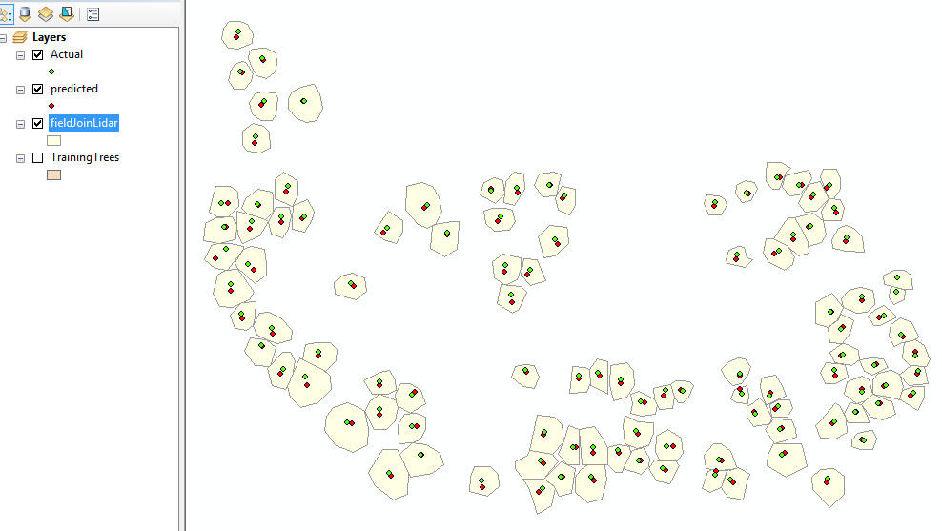

As it can be seen in the map above, there is a slight mismatch between the positions.

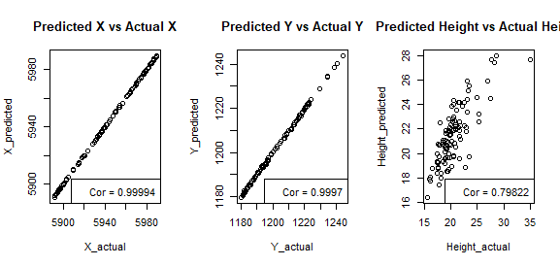

As shown in the scatter diagram above, and also the correlation, the accuracies are quite high but not perfect. The positional accuracies are better than that of the height. Latitude has the highest accuracy, followed by the longitude and the heght.

|  |  |  |  |  |  |
| --- | --- | --- | --- | --- | --- |
| RMSE_X | RMSE_Y | RMSE_H | MAE_X | MAE_Y | MAE_H |
| 0.34281 | 0.507849 | 2.008496 | 0.264904 | 0.412337 | 1.656411 |

The table shows the root mean square errors and the mean absolute errors of the various variables. Latitude has the least error, followed by the longitude and the height has the most error, although not so much. This further corroborates the scatter diagram and correlation earlier.

Analyse, are there some differences between different tree species?

|  |  |  |  |
| --- | --- | --- | --- |
| ID_Sp | rmseX | rmseY | rmseH |
| 1 | 0.265166 | 0.453207 | 1.80725 |
| 2 | 0.399468 | 0.551993 | 2.172139 |

In the above table, it is shown that species 2 has more error than species 1. In other words, the positional accuracies and the height accuracies of species 1 are higher than those of species 2.

Further visual explanation is provided by the diagrams below:

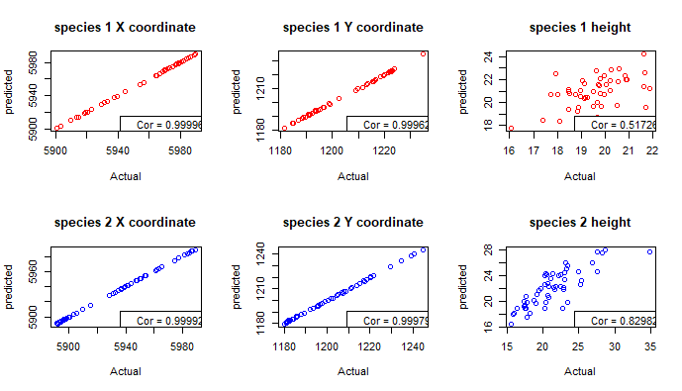

Return a pdf-file including:

• The modified R script

• Point height distributions of different tree species

• Conclusions of your error calculations

• Positioning error map